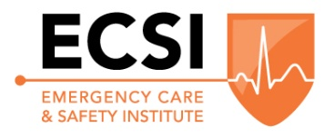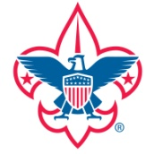
BSA Wilderness First Aid Course
The Longhouse Council is offering the Emergency Care and Safety Institute Wilderness First Aid Course (which meets the BSA Wilderness First Aid curriculum) on June 13-14, 2020. The course is 16 hours of classroom and skills instruction and will be taught by National Ski Patrol Certified Instructors. First Priority will be given to adult Boy Scout, Venturing, and Ship Leaders who will be participating in Back Country and High Adventure activities as part of their Unit Programs for 2020.
Class size is limited to the first 20 participants.
The course will be held at the Toggenburg Mountain Winter Sports Center, 1135 Toggenburg Road, Fabius, NY 13063 starting at 9:00 am and concluding at 5:00 pm both days.
Each participant is responsible for their own lunches as lunch is not provided.
Although practice first aid supplies will be provided, each participant should bring a first aid kit, suitable for a wilderness trip, for review and discussion during the class.
For more information please contact Walt Shepard at 315-637-8060 or 315-427-2834 or woshepard@verizon.net
Register online at https://longhouse.tentaroo.com/admin2/login

Course Cost: $50.00 / person
Course Fee includes:
- WFA Field Guide
- WFA Certification Card
- Small First Aid Training Kit
- Coffee, Bagles, Donuts, OJ, Bottled Water, and Snacks
- Paperwork Administration and Processing

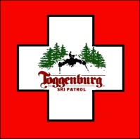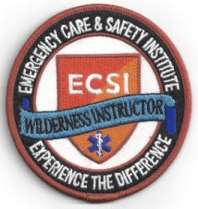

Wilderness First Aid Training Registration Form
Name:_________________________________ Phone:___________________ Unit#________
Address:____________________________ City:__________________ State:____ Zip:_______
Email:____________________________ District:_______________________
Credit Card_____-_____-_____-_____ CVV_____ Exp. Date_________ Visa/MC/Disc/Amex
Signature:_____________________________________
Please register online at the link above. If you are unable to do so, return this registration form with your payment (Check or Credit Card above) to:
Longhouse Council, BSA
2803 Brewerton Rd., Syracuse, NY 13211
Attn: Wilderness First Aid

