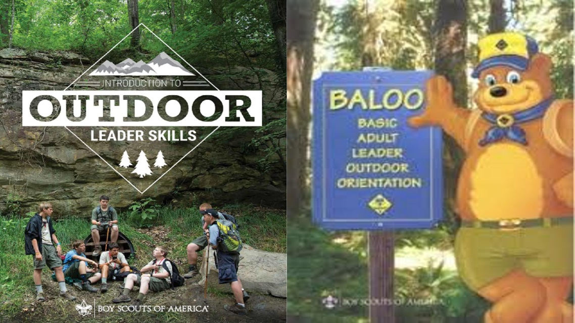
REGISTRATION PACKET FOR THE Longhouse council’s outdoor leader training for Cub and Scout leaders
October 6 & 7, 2018

Scout Leaders will have the opportunity to complete the Introduction to Outdoor Leadership Skills (IOLS). Cub Leaders will complete the outdoor component of the Basic Adult Leader Outdoor Orientation (BALOO) Training.
This course will begin at 8:00 am on Saturday October 6th and conclude by dinner on Sunday October 7th. The program will be held at Camp Woodland. A list of suggested equipment, clothing and supplies will be emailed to all registrants prior to the course. Accommodations for individuals with food allergies and other needs will be made.
Contact Thom Kubicki with any additional questions via e-mail or phone at:
Thomas.kubicki@oswego.edu or 315-796-9086
The cost for ALL participants will be $30. Please use the Registration on TENTAROO at https://longhouse.tentaroo.com/ or call the council office.
NOTE TO BOY SCOUT LEADERS: To attain the complete training for the Scoutmaster and Assistant Scoutmaster, the candidates must complete the Scoutmaster Specific Training prior to this Introduction to Outdoor Leader Skills (IOLS) course. This can be done using the online training available prior to the course. Those who have already completed the Scoutmaster Specific Training will be considered trained for their position upon completion of this course.

NOTE TO CUB SCOUT LEADERS: To attain the complete training for the Cub Leader BALOO certificate, the candidates must have completed the online training for the first part of BALOO prior to the course. In addition to the BALOO Training, the Cub Leaders will also complete the Introduction to Outdoor Leader Skills Training for Scout Leaders. If the Cub Scout Leader wishes to be fully trained in the as a Scoutmaster or Assistant Scoutmaster, the candidates must take the Scoutmaster Specific Training online or in a class in addition to this course.
PLEASE NOTE:
Registration deadline is Saturday, September29th.
No refunds will be authorized after this date. You may send another leader in your place. Contact council office to make those arrangements.

